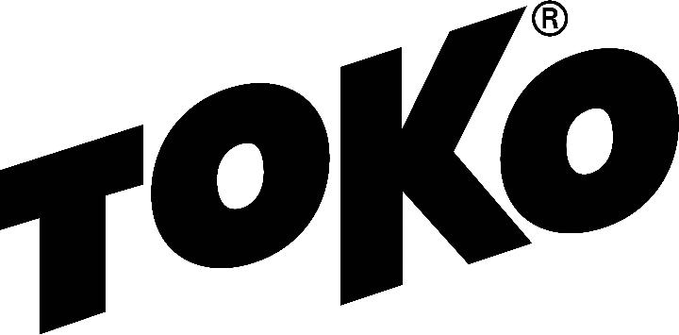

WAX RECOMMENDATION

Bogus Challenge Duathalon
Bogus Basin Nordic, Boise, ID
Saturday, December 19
3 P.M.
5K/3K/1K, Classic and Skate
Interval start
1 lap
https://www.webscorer.com/register?raceid=228876

Racing - Service

Forecast/Conditions: New snow throughout week, expect soft untransformed snow. Friday night low of 27, Saturday high of 31 and 29 at start, 70 percent cloud cover, 20 percent chance of snow during race.

Glidewax: Apply Base Performance Blue Hot Wax, scrape and brush. Spray on Base Performance Red Liquid Paraffin, let stand overnight, then polish with the Polishing Brush Liquid Paraffin. If you do not have LP spray, after scraping and brushing BP Blue Hot Wax, apply BP Red Hot Wax, scrape and brush.

Gripwax: Roughen base with 150 grit sandpaper, iron in Nordic Base Wax Green, cork smooth, let cool. Then apply 2 layers of Nordic GripWax Red, corking between layers. If conditions are warmer than predicted or tracks are glazed, substitute first layer with a light layer of Nordic GripWax Yellow.

Structure: A universal structure covered by one pass with the Red Structurite tool after scraping and brushing final BP Hot Wax or before spraying BP LP will best suit these conditions.

Created by Randy Anderson, Toko Tech Team member since 2015. Randy@TokoUS.com
Check the Wax Tips page at TokoUS.com before all of your races for the latest waxing information. Toko Race Wax Tips offer racers precise waxing advice on how to make skis perform optimally for a given event. If an event allows fluorinated waxes and you choose to use them, use High Performance or Performance (Liquid Paraffin or Hot Wax) of the same color (Yellow, Red or Blue), as the temperature ranges are the same. To see optimal application procedures for both Glidewax and Gripwax, go to the How To link at TokoUS.com.

