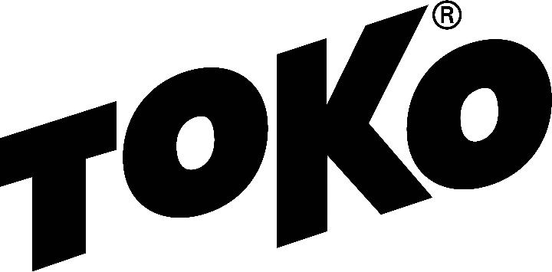­

## WAX RECOMMENDATION

# **Lakes of the North Freestyle**

Lakes of the North, Mancelona, MI

Saturday, December 15

11 A.M.

7K, Freestyle

Wave start

http://www.nordicskiracer.com/event-details.asp?id=2674

### Racing - Service

Forecast/Conditions: Friday high in the upper 30s, Friday night low in the low 20s. Race start temperature around 30 rising to 35 by noon. Light wind, mostly clear. Snow is mostly clean, slightly transformed and perhaps icy in the shadows.

[Glidewax:](https://tokous.com/video-hot-waxing-technique-cross-country/) Apply LF Black, scrape and brush, then apply HF Red/HF Yellow mixed 1/1, scrape and brush. Finish by crayoning JetStream Yellow, iron hot (320F) with a layer of fiberlene under the iron, traveling slowly (60 seconds) tip to tail. Brush with a dedicated nylon polishing brush and polish with a thermopad.

[Gripwax:](https://tokous.com/video-grip-wax-application-to-cross-country-skis/) N/A

[Structure:](https://tokous.com/video-using-the-structurite-cross-country/) A universal structure covered by one pass with the Red Structurite tool (before JetStream application) will best suit these conditions.

Check the [Wax Tips](https://tokous.com/category/wax-tips/) page at [TokoUS.com](https://tokous.com/) before all of your races for the latest waxing information. The Toko Race Wax Tips offer racers precise waxing advice on how to make your skis perform optimally for a given event. For racers who don’t have top end waxes, skip the Fluorocarbon (JetStream or HelX) and substitute the LF or NF wax of the same color (Yellow, Red or Blue). To see optimal application procedures for both Glidewax and Gripwax, go to the How To link at [TokoUS.com](http://www.tokous.com/).