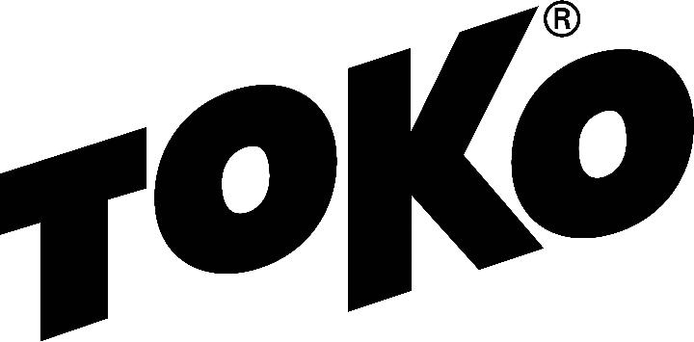

WAX RECOMMENDATION

New York State Public High School Championships
North Creek, NY, Gore Mountain
Tuesday, February 27, 2018
10:00 A.M.
3x3km Relay girls and boys, classical technique
http://www.nysphsaa.org/News-Media/Headline-News/Article/id/2553

Racing - Service

Forecast/Conditions: Overnight low 20, temperature at start 33, man-made, machine groomed, transformed snow and sunny

Glidewax: Apply LF Black, scrape and brush, then apply HF Yellow, scrape and brush. Finish by crayoning JetStream Yellow, iron hot (320F) with a layer of fiberlene under the iron, traveling slowly (60 seconds) tip to tail. Brush with a dedicated nylon polishing brush and polish with a thermopad.

Gripwax: Testing at race site required, TBD

Structure: A wet structure covered by one pass with the Yellow Structurite tool (before JetStream application) will best suit these {conditions.

Created by Duncan Douglas, Toko Tech Team, douglas6xc@gmail.com
Check the Wax Tips page at TokoUS.com before all of your races for the latest waxing information. The Toko Race Wax Tips offer racers precise waxing advice on how to make your skis perform optimally for a given event. For racers who don’t have top end waxes, skip the Fluorocarbon (JetStream or HelX) and substitute the LF or NF wax of the same color (Yellow, Red or Blue). To see optimal application procedures for both Glidewax and Gripwax, go to the How To link at TokoUS.com.

