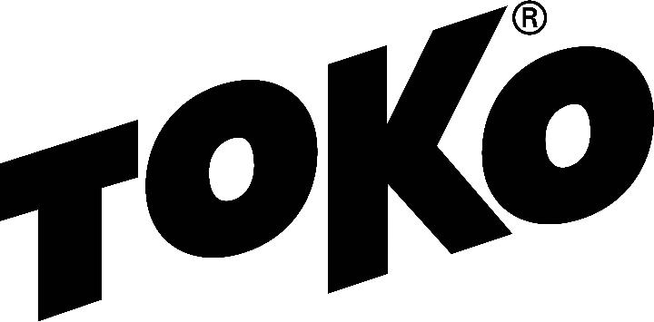­

## WAX RECOMMENDATION

# **New York State Public High School Championships**

North Creek, NY, Gore Mountain

Monday, February 26, 2018

10:00 A.M.

5k girls; 10k boys, freestyle technique

Individual Start, multiple laps

http://www.nysphsaa.org/News-Media/Headline-News/Article/id/2553

### Racing - Service

Forecast/Conditions: Overnight low 28, temperature at start 37, man-made, machine groomed, transformed snow and sunny

[Glidewax:](https://tokous.com/video-hot-waxing-technique-cross-country/) Apply LF Black, scrape and brush, then apply HF Yellow, scrape and brush. Finish by crayoning JetStream Yellow, iron hot (320F) with a layer of fiberlene under the iron, traveling slowly (60 seconds) tip to tail. Brush with a dedicated nylon polishing brush and polish with a thermopad.

[Gripwax:](https://tokous.com/video-grip-wax-application-to-cross-country-skis/) N/A

[Structure:](https://tokous.com/video-using-the-structurite-cross-country/) A wet structure covered by one pass with the Yellow Structurite tool (before JetStream application) will best suit these {conditions.

Created by Duncan Douglas, Toko Tech Team, douglas6xc@gmail.com

Check the [Wax Tips](https://tokous.com/category/wax-tips/) page at [TokoUS.com](https://tokous.com/) before all of your races for the latest waxing information. The Toko Race Wax Tips offer racers precise waxing advice on how to make your skis perform optimally for a given event. For racers who don’t have top end waxes, skip the Fluorocarbon (JetStream or HelX) and substitute the LF or NF wax of the same color (Yellow, Red or Blue). To see optimal application procedures for both Glidewax and Gripwax, go to the How To link at [TokoUS.com](http://www.tokous.com/).